11/20/2024

Sprint 3

Team Name: Entrepreneurial Code Crafters

Contents

**Availability of Group members** 1

The Domain Analysis 1

Key Entities 1

Processes 2

Scope and Requirements 2

User Journey Diagram 3

Architecture and Technology Choices 4

Technology Stack: 4

Architecture: 4

The Platform Mock-Up 5

# **Availability of Group members**

Njeje Lilitha: ST10083978 (100%)

Ndlovu Malibongwe: ST10083947 (100%)

Gopal Allison: ST10083717 (100%)

Kunene Sbahle Sibusisiwe: ST10083915 (100%)

Hayley Hananiah Chetty: ST10083771 (100%)

Arven Sewlal: ST10083252 (100%)

# The Domain Analysis

### **Key Entities**

1. **Student:**
   * Attributes: StudentNum, FirstName, LastName, Email, Password, BusinessProposal, Uploads Resources.
   * Relationships:
     + The Student will submit the business proposals to the mentor/investors.
     + They will also interact with mentors for guidance on how to go about the proposal.
2. **Mentor:**
   * Attributes: MentorID, FirstName, LastName, Email, Password
   * Relationships:
     + Provides guidance to the students.
     + They will participates in discussions and in the sharing of the resources.
3. **Admin:**
   * Attributes: AdminID, FirstName, LastName, Email, Password
   * Relationships:
     + They accept or decline the business showcase.
     + They verify the business showcase
4. **Business Proposal:**
   * Attributes: BusinessProposalID, ProblemSoultion, MentorID, StudentNum, SubmissionID, FeedBackID(Pending/Approved/Rejected), Description
   * Relationships:
     + The proposal is submitted by the students.
     + The mentor will review the proposal and send feedback to the students.
5. **Resources:**
   * Attributes: ResourceID, Title, Content, UploadofRecorces.
   * Relationships:
     + Shared by the mentors.
     + Accessible to all platform users.
6. **Networking :**
   * Attributes: StudentNum, MentorID
   * Relationships:
     + The students and the mentors will have an interaction.

### **Processes**

1. **User Registration and Profile Creation:**
   * All users register with specific roles (Students, Mentor, Admin).
   * Users create profiles
2. **Proposal Submission:**
   * The students are required to upload proposals with a Business Name, description and their contact details.
   * Proposals are visible to the mentors for review and feedback.
3. **Networking and Connections:**
   * The students can chat, collaborate, and share resources with the mentors.
4. **Resource Sharing:**
   * All the articles, templates, and guides will be accessible to the students.

### **Scope and Requirements**

#### **1. Resource Sharing**

* **Features:**
  + Upload the helpful resources for the students (e.g., articles, guides, templates).
  + Categorize resources in order to be easily accessed.
  + Allow users to download the resources.
* **Requirements:**
  + Needs a scalable storage for all the documentation and multimedia.
  + User-friendly interface for uploads.

#### **2. Proposal Submission**

* **Features:**
  + Templates for students to upload business proposals.
  + Interacts with the mentor to know their status (Pending, Approved, and Rejected).
  + Allow investors to provide feedback on proposals.
* **Requirements:**
  + Database to store proposals.
  + Notification system for status updates.

# User Journey Diagram

**1. Student User Journey**

The student will firstly Login/Registration, they will then submit proposals, network with other students, view notifications, Access resources like videos and feedback from mentors.

They are given access to browse through templates for business plans. They then need to submit questions or receive real-time feedback

**2. Mentor User Journey**

The mentor will login and enter their credentials in order to gain access into the platform. They will review the submissions made by the students. They can search for the business proposals or the funding guide by entering the student number.

**3. Admin User Journey**

**They will also login by entering their credentials, and they will** upload, update, or remove business templates and guides. The admin will monitor mentoring sessions and platform

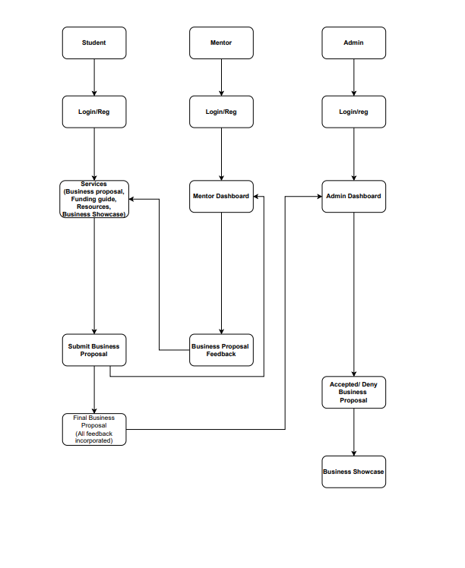

# Architecture and Technology Choices

# Technology Stack:

* **Frontend**: Asp.NET (MVC) using bootstrap for building a responsive and interactive user interface using C#. This IDE is flexible, it is widely adopted and is cost effective.
* **Backend**: C# Asp.NET with SSMS for a scalable and efficient server-side application. We decided to use these because they are secured, they integrate well with MS Ecosystems
* **Database**: During development, SSMS for a flexible and scalable database. This database choice is compatible with MVC
* **Authentication**: During development, we will create a custom user registration and log in. this allows us to have a complete control over user data and security measures.

Architecture:

We will adopt micro-services architecture for modularity, ease of maintenance as well as scalability. This architecture enables independent development, it allows deployment as well as scaling components

The pattern we will use is MVC Pattern to organize and maintain code structure, this pattern promotes separation of concerns

We will also integrate API Gateways to securely manage API Access. API gateways provides centralized security as well as monitoring.

# The Platform Mock-Up

The link to the mock-up:

<https://allisongopal.wixsite.com/entrepreneurial-code>

Screenshots of the mock-up:

HOME PAGE

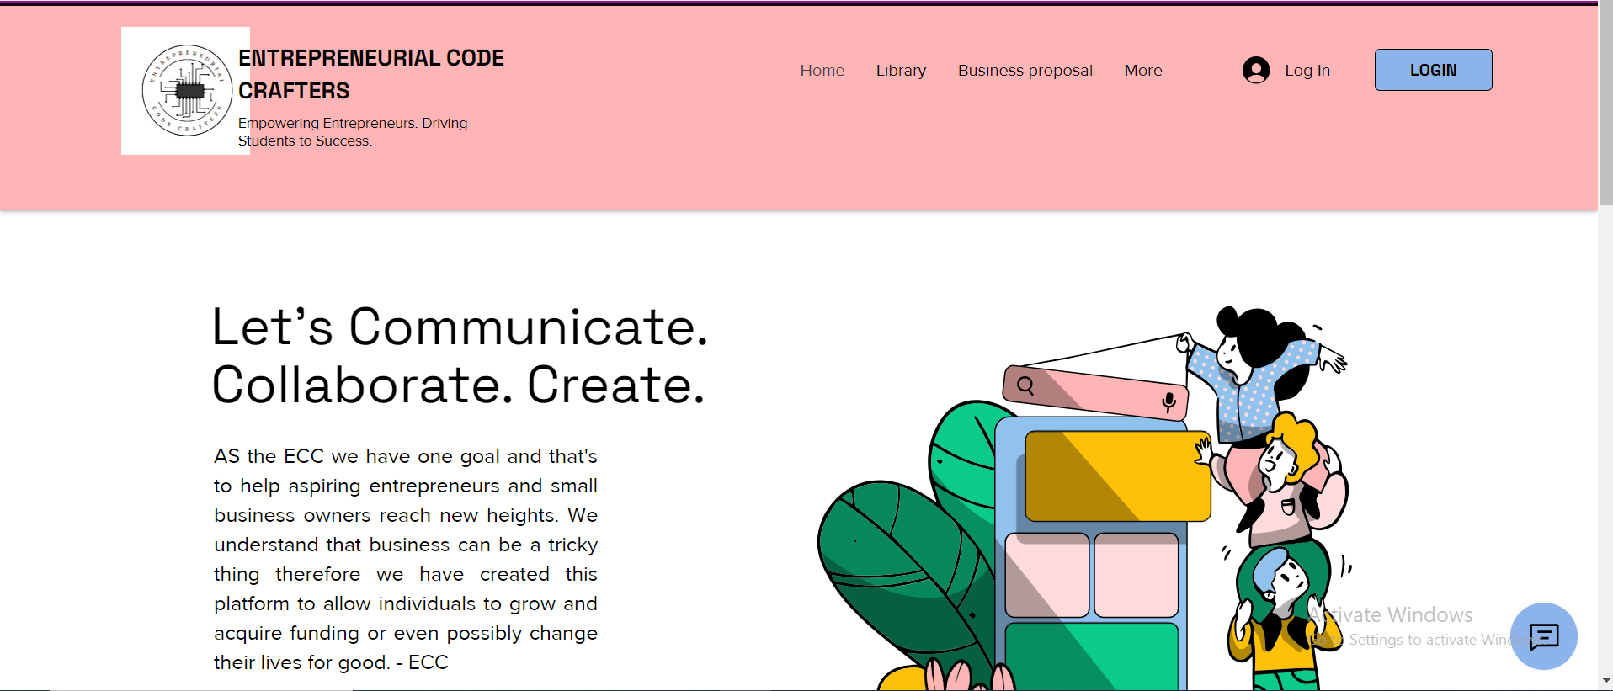

BUSINESS PROPOSAL

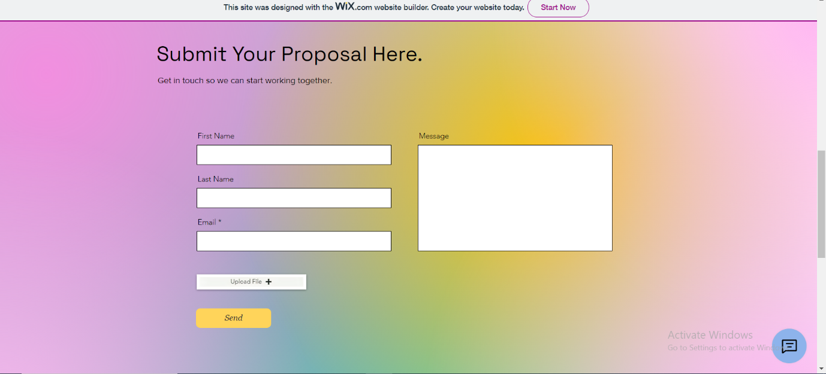

OPTION LIST

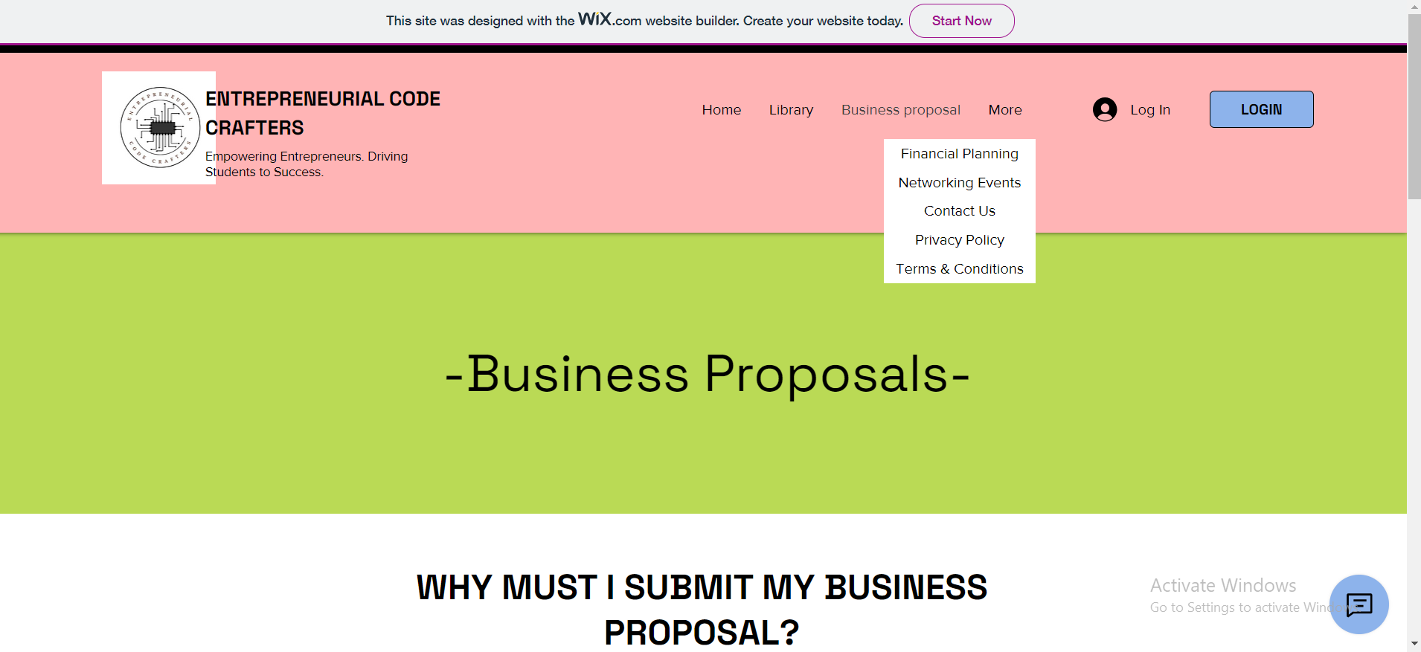

FINANICAL PLANNING

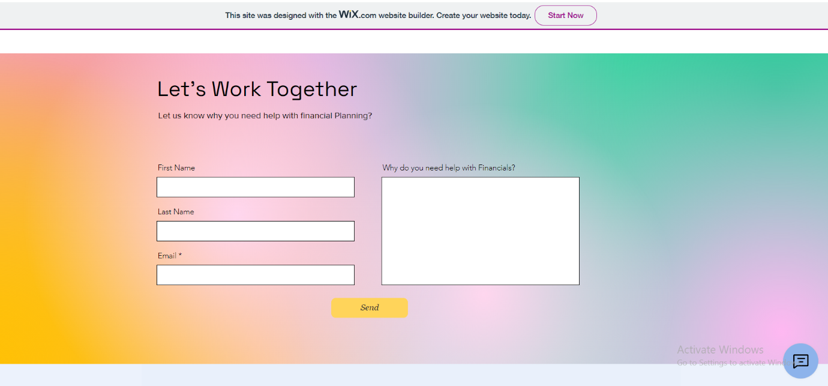

NETWORKING EVENTS

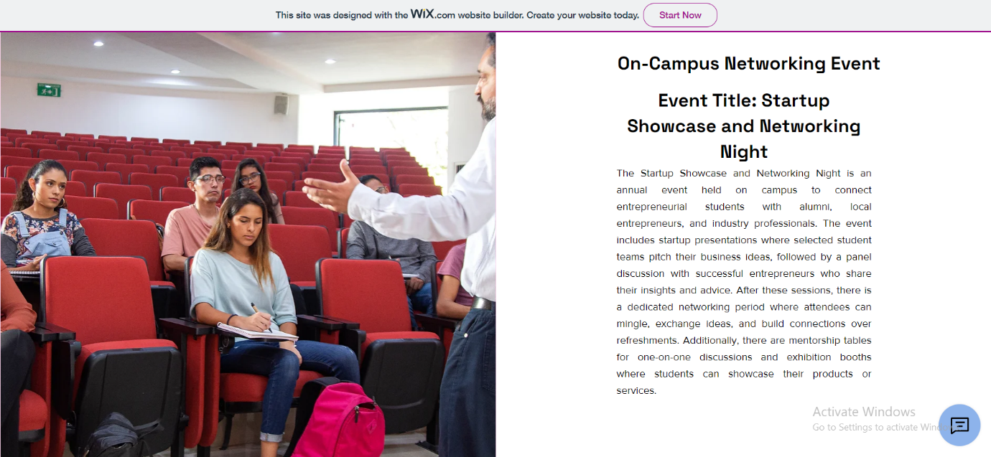

CONTACT US

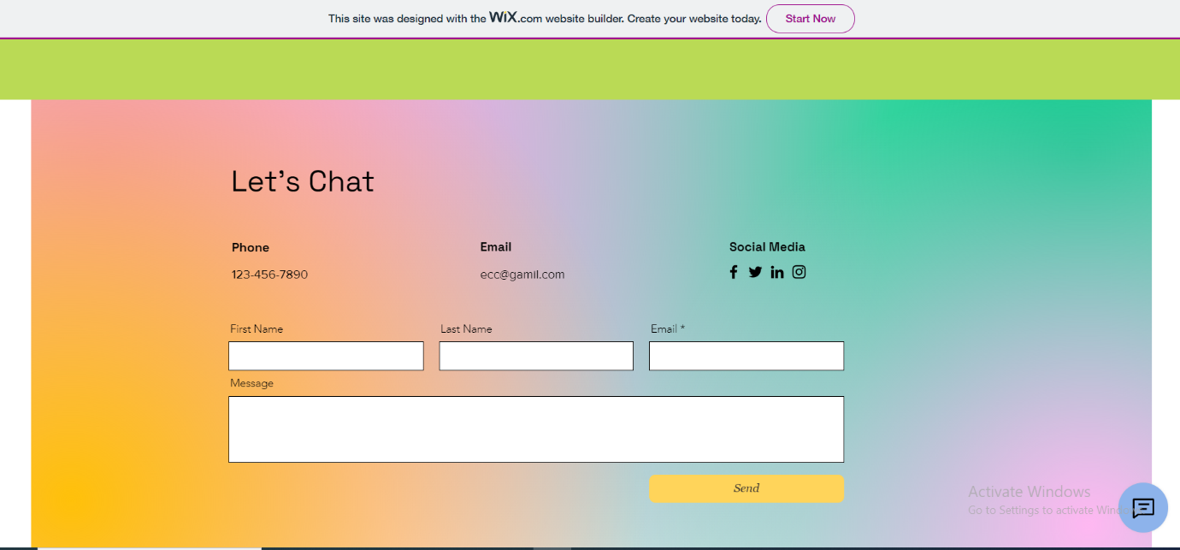

PRIVACY POLICY

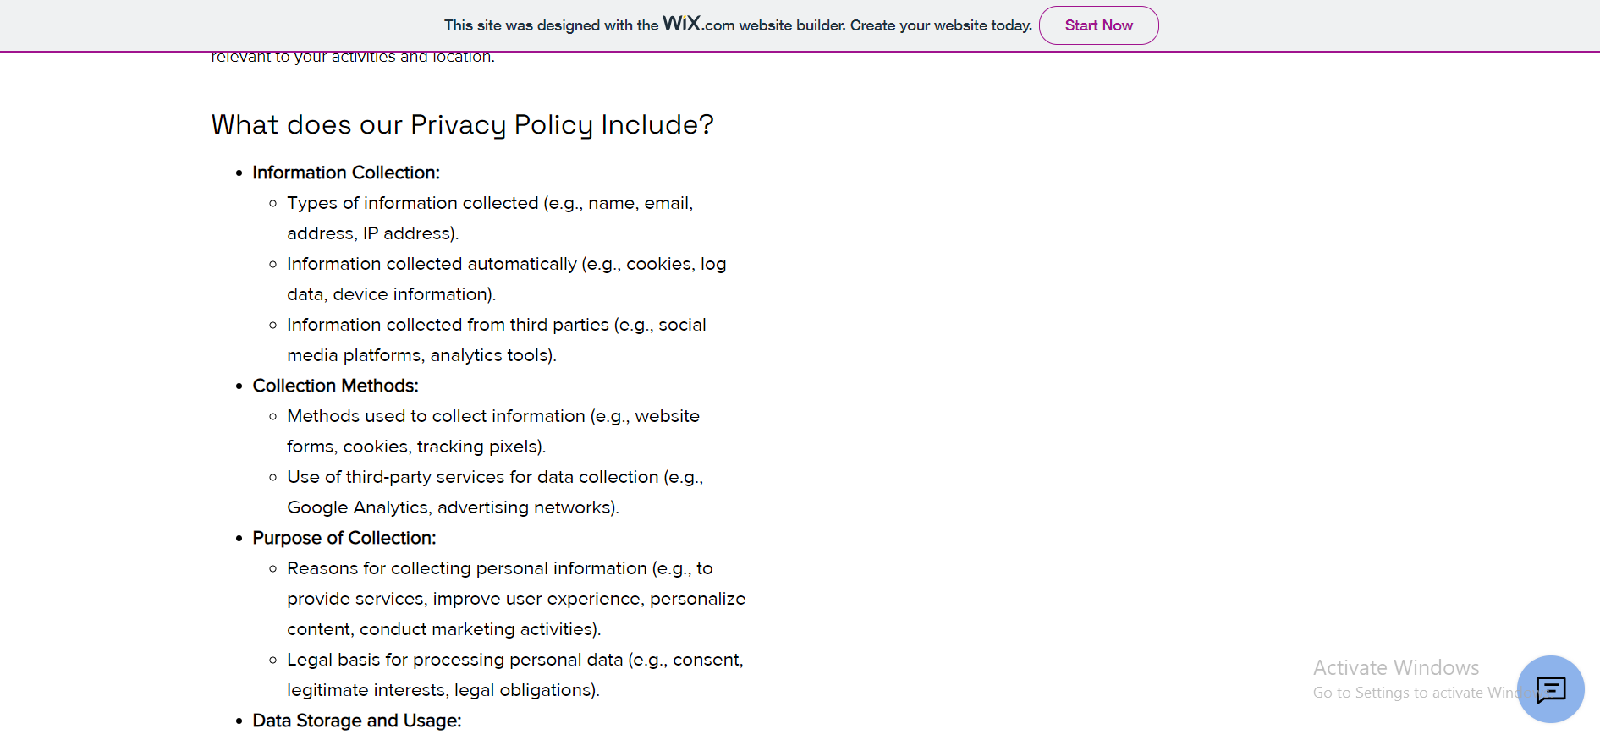

TERMS AND CONDITIONS

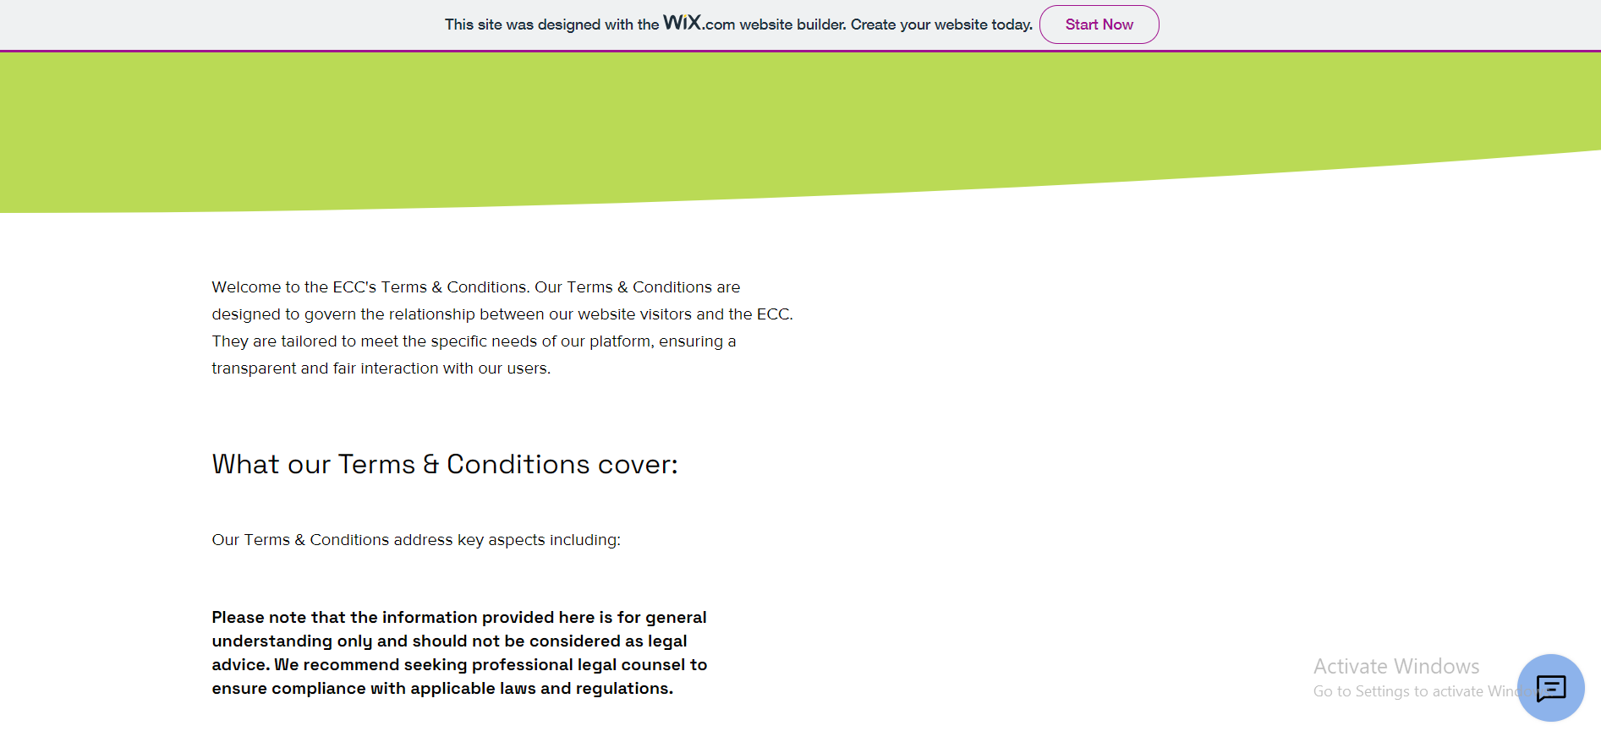

LIBRARY

